COVID 19 Cases in Greater Toronto Area by Public Health Unit
As of April 25, 2021
 | # of People Infected | # of Deaths | # of People Recovered
Durham Region Health Department | 19,678 | 335 | 17,326
Halton Region Health Department | 13,983 | 207 | 12,350
Peel Public Health | 88,804 | 677 | 79,241
Toronto Public Health | 138,258 | 2,990 | 122,403
York Region Public Health Services | 44,499 | 646 | 40,078
Overall GTA | 305,222 | 4,855 | 27,1398

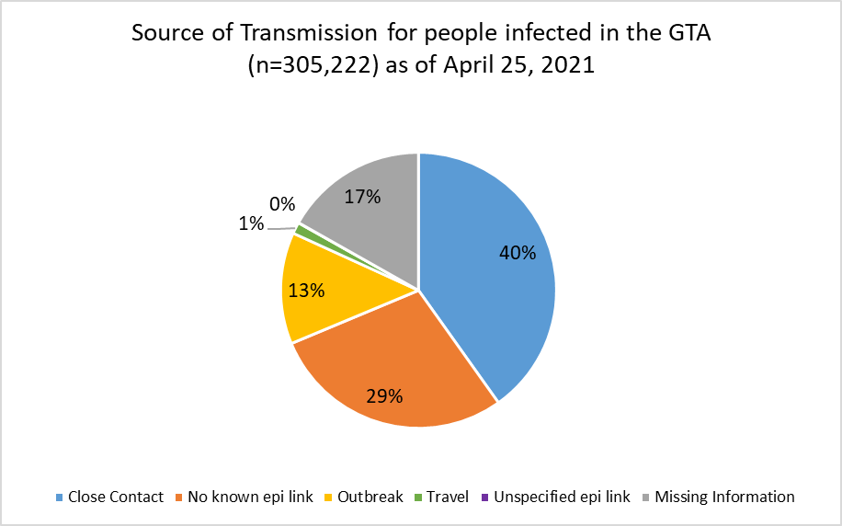
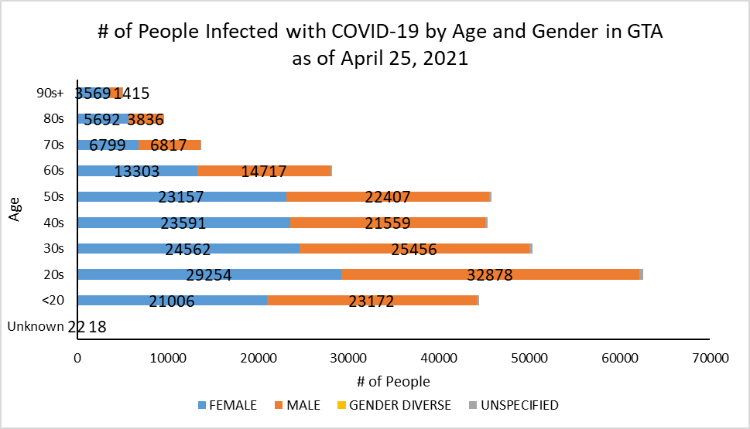
Footnote: There are a total of 24 cases where gender was indicated as “Gender Diverse” and another 1968 cases where gender was unspecified.
Source: Data as of April 25, 2021 (extracted from https://data.ontario.ca/dataset/confirmed-positive-cases-of-covid-19-in-ontario)

