COVID 19 Cases in Greater Toronto Area by Public Health Unit
As of April 13, 2021
 | # of People Infected | # of Deaths | # of People Recovered
Durham Region Health Department | 16,865 | 311 | 14,571
Halton Region Health Department | 12,252 | 200 | 10,669
Peel Public Health | 78,285 | 646 | 70,710
Toronto Public Health | 123,695 | 2,853 | 109,276
York Region Public Health Services | 39,149 | 619 | 34,920
Overall GTA | 270,246 | 4,629 | 240,146

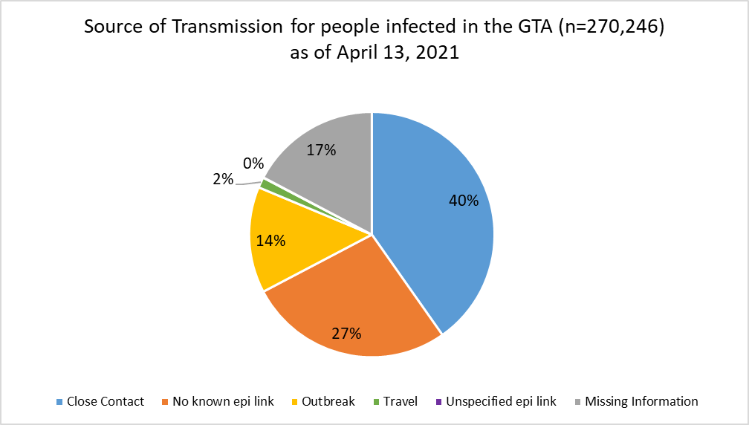
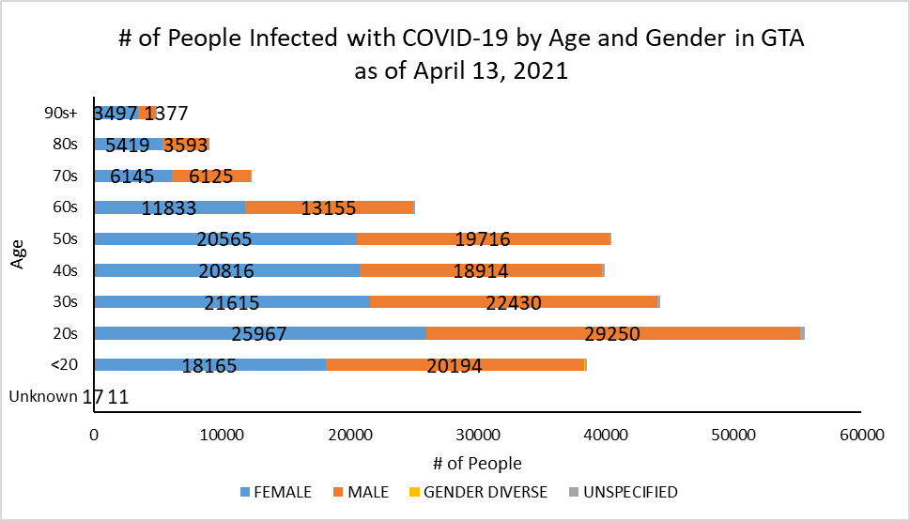
Footnote: There are a total of 24 cases where gender was indicated as “Gender Diverse”) and another 1418 cases where gender was unspecified.
Source: Data as of April 13, 2021 (extracted from https://data.ontario.ca/dataset/confirmed-positive-cases-of-covid-19-in-ontario)

