COVID 19 Cases in Greater Toronto Area by Public Health Unit
As of March 2, 2021
 | # of People Infected | # of Deaths | # of People Recovered
Durham Region Health Department | 11,917 | 298 | 11,366
Halton Region Health Department | 9,241 | 196 | 8,743
Peel Public Health | 61,475 | 615 | 58,613
Toronto Public Health | 94,899 | 2,640 | 88,929
York Region Public Health Services | 28,941 | 559 | 27,645
Overall GTA | 206,473 | 4,308 | 195,296

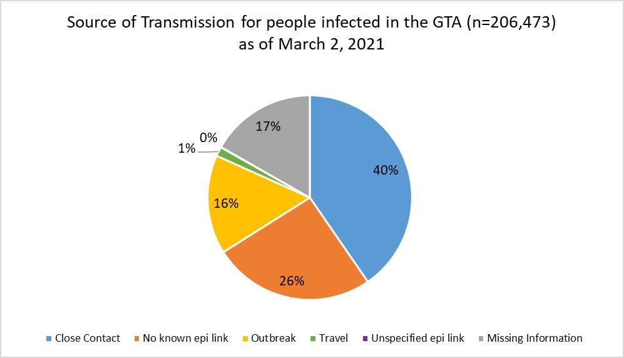
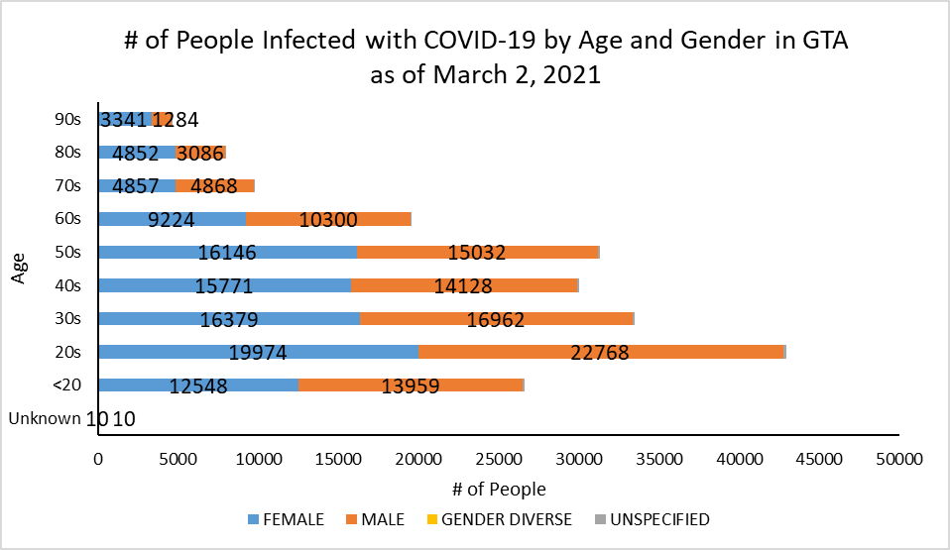
Footnote: There are a total of 22 cases where gender was indicated as “Gender Diverse”) and another 952 cases where gender was unspecified.
Source: Data as of March 2, 2021 (extracted from https://data.ontario.ca/dataset/confirmed-positive-cases-of-covid-19-in-ontario)

