COVID 19 Cases in Greater Toronto Area by Public Health Unit
As of January 24, 2021
 | # of People Infected | # of Deaths | # of People Recovered
Durham Region Health Department | 10,266 | 270 | 9,394
Halton Region Health Department | 7,769 | 151 | 6,876
Peel Public Health | 52,506 | 537 | 47,179
Toronto Public Health | 80,060 | 2,300 | 70,006
York Region Public Health Services | 24,354 | 461 | 22,331
Overall GTA | 174,955 | 3,719 | 155,786

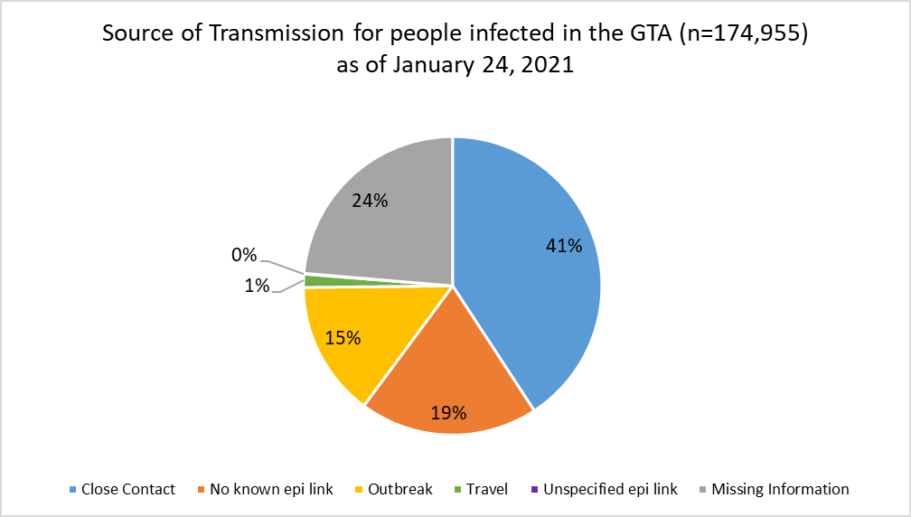
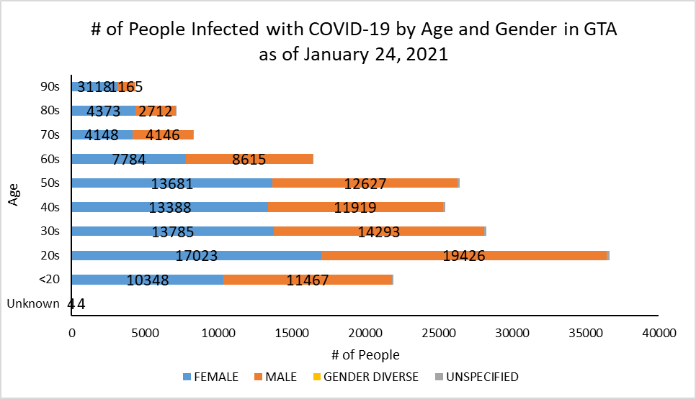
Footnote: There are a total of 21 cases where gender was indicated as “Gender Diverse”) and another 908 cases where gender was unspecified.
Source: Data as of January 24, 2021 (extracted from https://data.ontario.ca/dataset/confirmed-positive-cases-of-covid-19-in-ontario)

