COVID 19 Cases in Greater Toronto Area by Public Health Unit
As of January 12, 2021
 | # of People Infected | # of Deaths | # of People Recovered
Durham Region Health Department | 9,192 | 249 | 7,983
Halton Region Health Department | 6,919 | 136 | 5,762
Peel Public Health | 46,621 | 498 | 40,574
Toronto Public Health | 70,168 | 2,076 | 59,332
York Region Public Health Services | 21,541 | 418 | 18,592
Overall GTA | 154,441 | 3,377 | 132,243

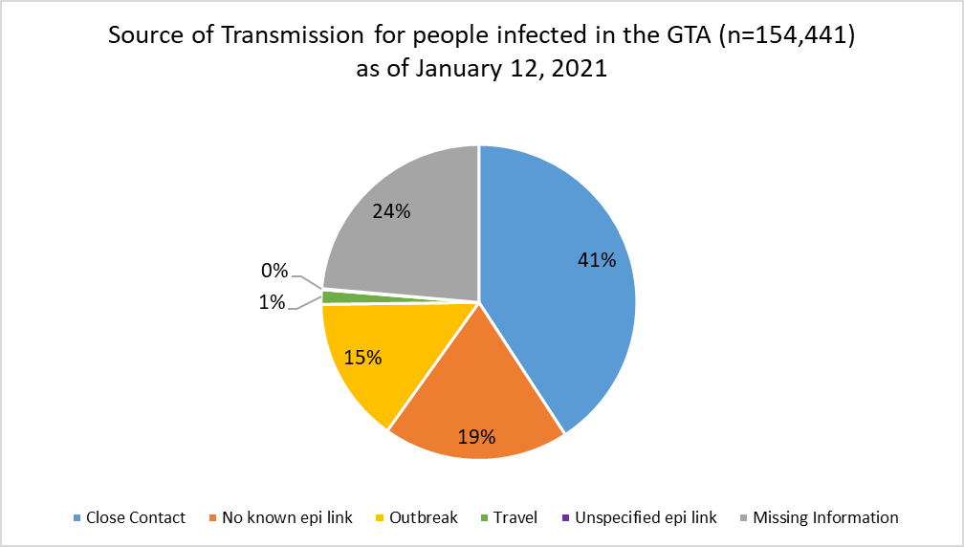
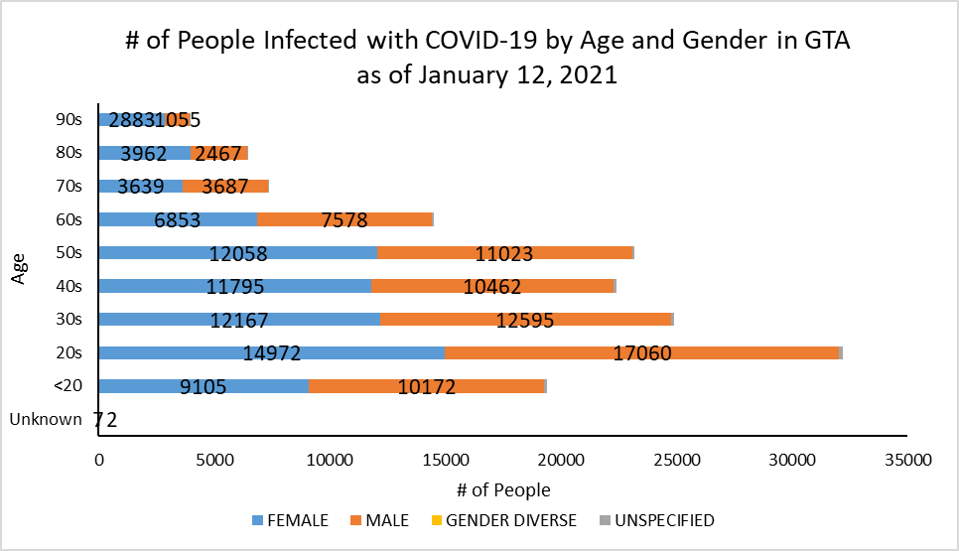
Footnote: There are a total of 20 cases where gender was indicated as “Gender Diverse”) and another 879 cases where gender was unspecified.
Source: Data as of January 12, 2021 (extracted from https://data.ontario.ca/dataset/confirmed-positive-cases-of-covid-19-in-ontario)

