COVID 19 Cases in Greater Toronto Area by Public Health Unit
As of November 24, 2020
 | # of People Infected | # of Deaths | # of People Recovered
Durham Region Health Department | 4,100 | 183 | 3,546
Halton Region Health Department | 3,183 | 54 | 2,713
Peel Public Health | 22,891 | 357 | 18,560
Toronto Public Health | 37,228 | 1,533 | 31,380
York Region Public Health Services | 9,932 | 307 | 8,397
Overall GTA | 77,334 | 2,434 | 64,596

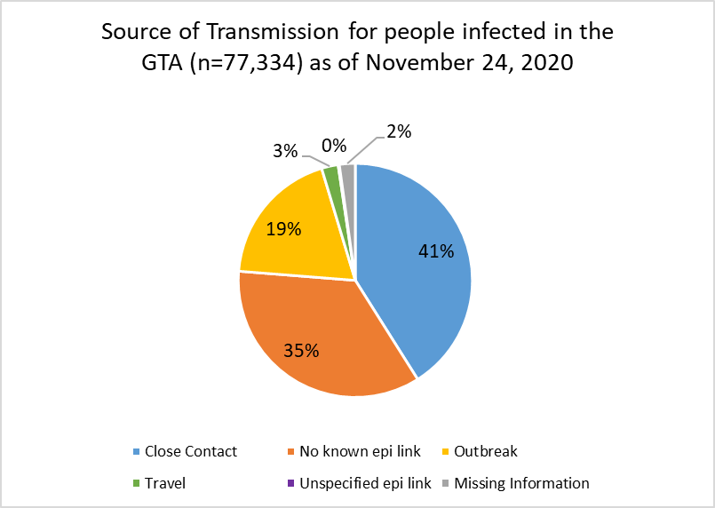
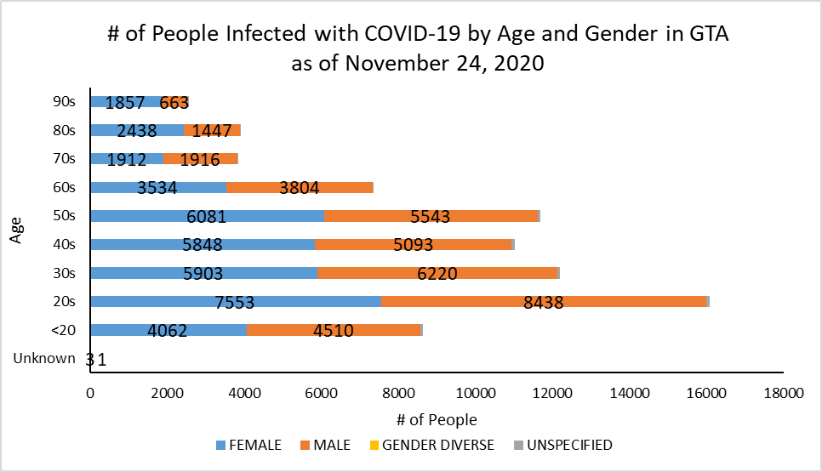
Footnote: There are a total of 15 cases where gender was indicated as “Gender Diverse”) and another 493 cases where gender was unspecified.
Source: Data as of November 24, 2020 (extracted from https://data.ontario.ca/dataset/confirmed-positive-cases-of-covid-19-in-ontario)

