COVID 19 Cases in Greater Toronto Area by Public Health Unit
As of October 22, 2020
 | # of People Infected | # of Deaths | # of People Recovered
Durham Region Health Department | 2,718 | 182 | 2,361
Halton Region Health Department | 1,821 | 30 | 1,597
Peel Public Health | 12,184 | 327 | 10,712
Toronto Public Health | 24,303 | 1,319 | 20,312
York Region Public Health Services | 5,859 | 266 | 4,797
Overall GTA | 46,885 | 2,124 | 39,779

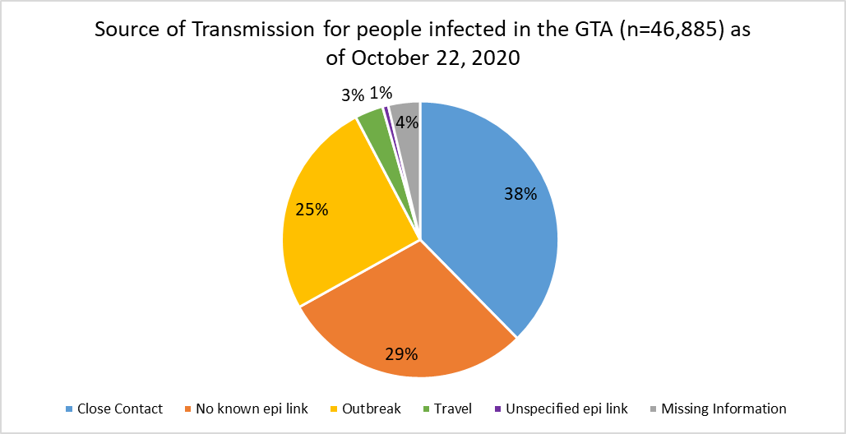
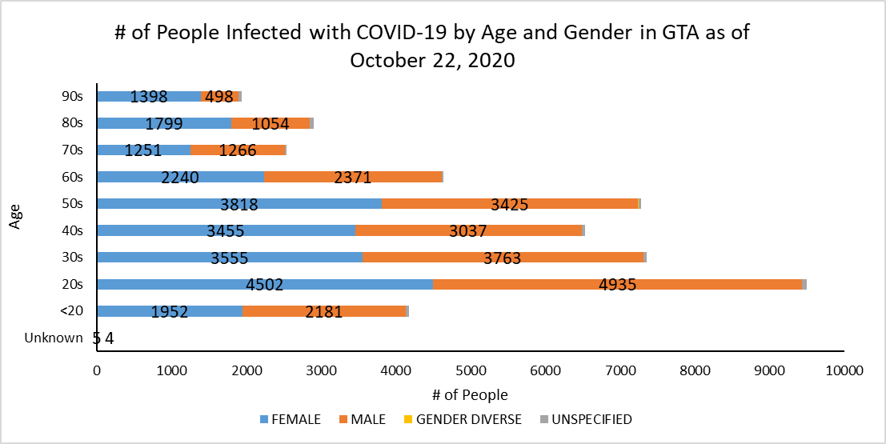
Footnote: There are a total of 9 cases where gender was indicated as “Gender Diverse”) and another 367 cases where gender was unspecified.
Source: Data as of October 22, 2020 (extracted from https://data.ontario.ca/dataset/confirmed-positive-cases-of-covid-19-in-ontario)

