COVID 19 Cases in Greater Toronto Area by Public Health Unit
As of October 13, 2020
 | # of People Infected | # of Deaths | # of People Recovered
Durham Region Health Department | 2,418 | 181 | 2,140
Halton Region Health Department | 1,537 | 27 | 1,336
Peel Public Health | 10,842 | 325 | 9,557
Toronto Public Health | 21,761 | 1,300 | 18,074
York Region Public Health Services | 5,062 | 258 | 4,210
Overall GTA | 41,620 | 2,091 | 35,317

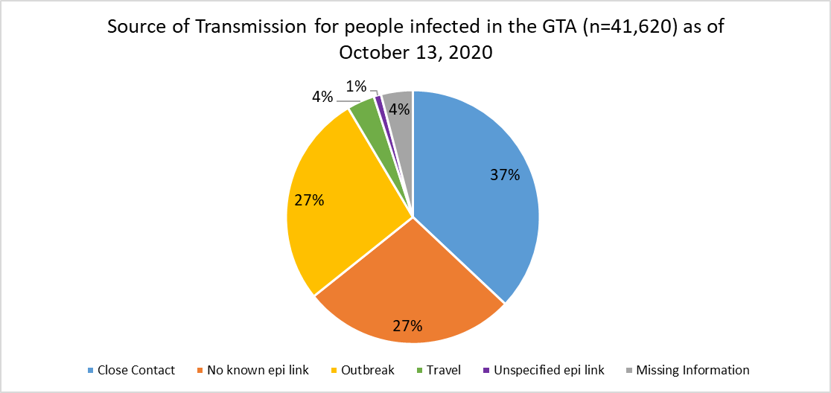
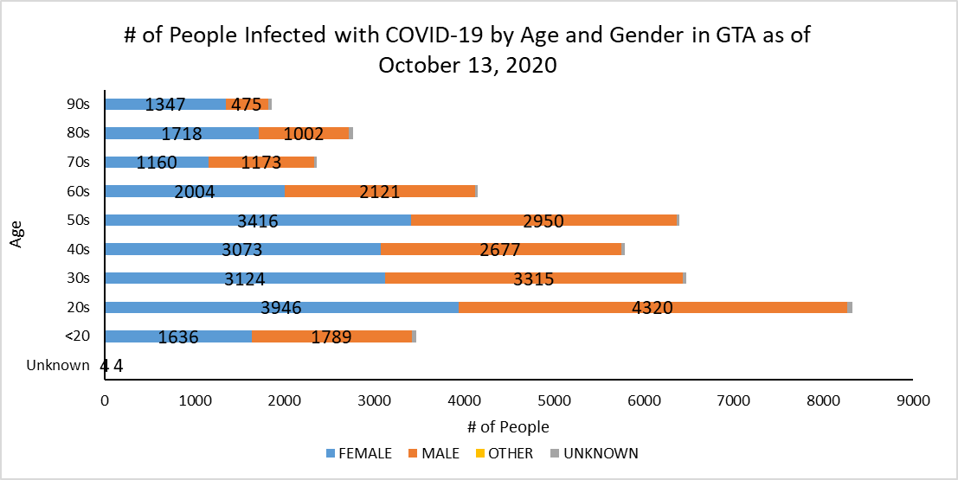
Footnote: There are a total of 14 cases where gender was indicated as “Other” (including “Transgender”) and another 352 cases where gender was unknown.
Source: Data as of October 13, 2020 (extracted from https://data.ontario.ca/dataset/confirmed-positive-cases-of-covid-19-in-ontario)

