COVID 19 Cases in Greater Toronto Area by Public Health Unit
As of September 24, 2020
 | # of People Infected | # of Deaths | # of People Recovered
Durham Region Health Department | 2,091 | 181 | 1,821
Halton Region Health Department | 1,094 | 25 | 935
Peel Public Health | 8,606 | 321 | 7,502
Toronto Public Health | 16,932 | 1,155 | 14,427
York Region Public Health Services | 3,984 | 253 | 3,401
Overall GTA | 32,707 | 1,935 | 28,086

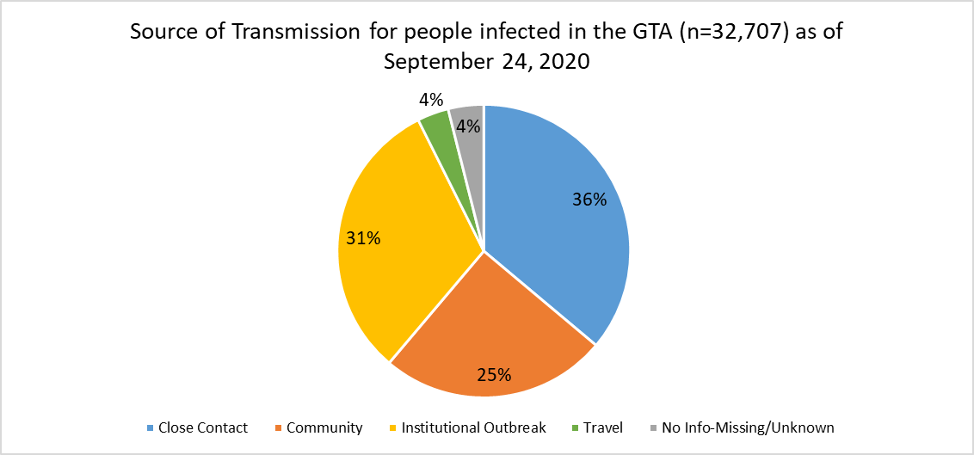
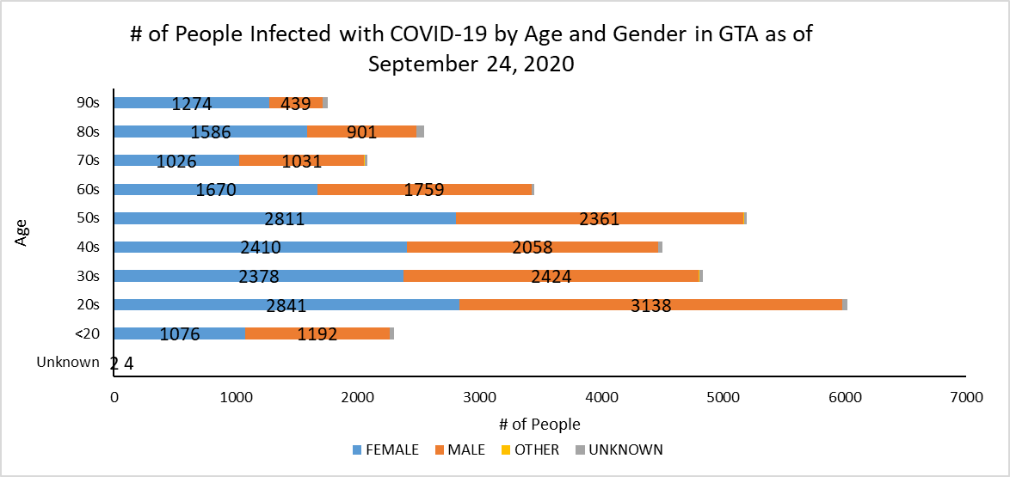
Footnote: There are a total of 12 cases where gender was indicated as “Other” (including “Transgender”) and another 314 cases where gender was unknown.
Source: Data as of September 24, 2020 (extracted from https://data.ontario.ca/dataset/confirmed-positive-cases-of-covid-19-in-ontario)

