COVID 19 Cases in Greater Toronto Area by Public Health Unit
As of July 26, 2020
 | # of People Infected | # of Deaths | # of People Recovered
Durham Region Health Department | 1,795 | 181 | 1,592
Halton Region Health Department | 824 | 25 | 777
Peel Public Health | 6,503 | 314 | 5,918
Toronto Public Health | 14,097 | 1,124 | 12,659
York Region Public Health Services | 3,233 | 250 | 2,905
Overall GTA | 26,452 | 1,894 | 23,851

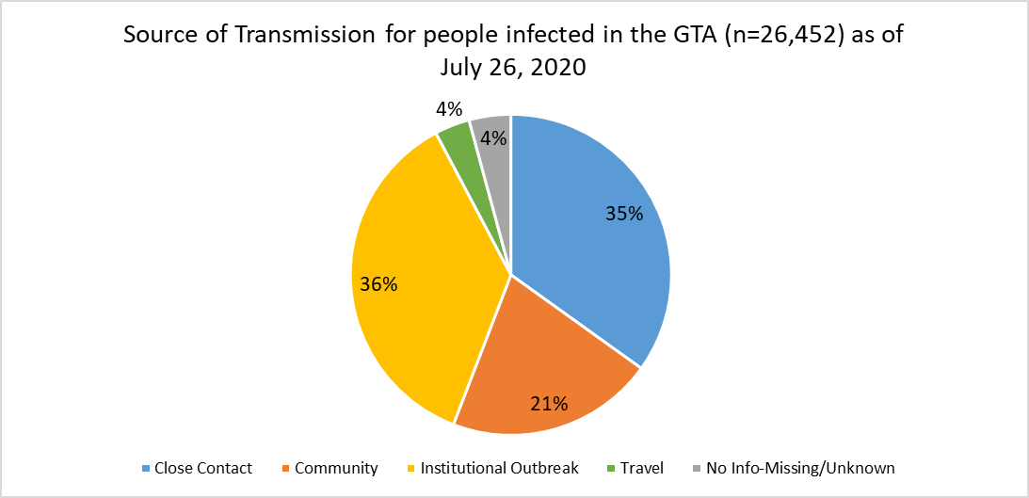
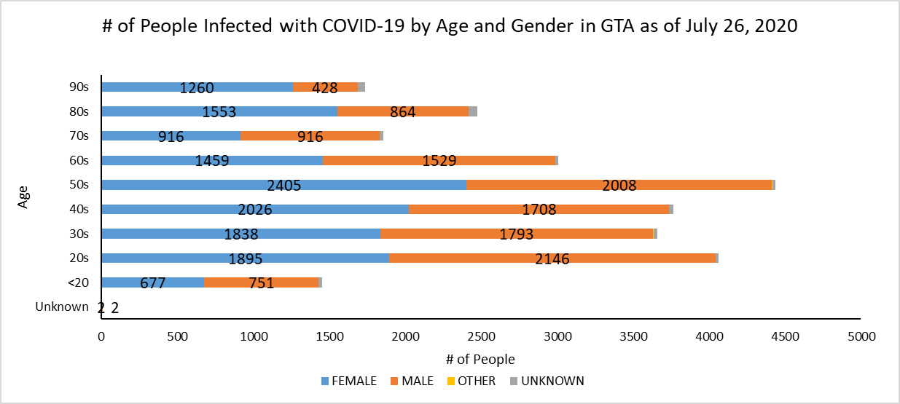
Footnote: There are a total of 13 cases where gender was indicated as “Other” (including “Transgender”) and another 263 cases where gender was unknown.
Source: Data as of July 26, 2020 (extracted from https://data.ontario.ca/dataset/confirmed-positive-cases-of-covid-19-in-ontario)

