COVID 19 Cases in Greater Toronto Area by Public Health Unit
As of July 2, 2020
 | # of People Infected | # of Deaths | # of People Recovered
Durham Region Health Department | 1,703 | 180 | 1,487
Halton Region Health Department | 761 | 25 | 695
Peel Public Health | 5,867 | 306 | 5,133
Toronto Public Health | 13,306 | 1,065 | 11,613
York Region Public Health Services | 3,012 | 244 | 2,605
Overall GTA | 24,649 | 1,820 | 21,533

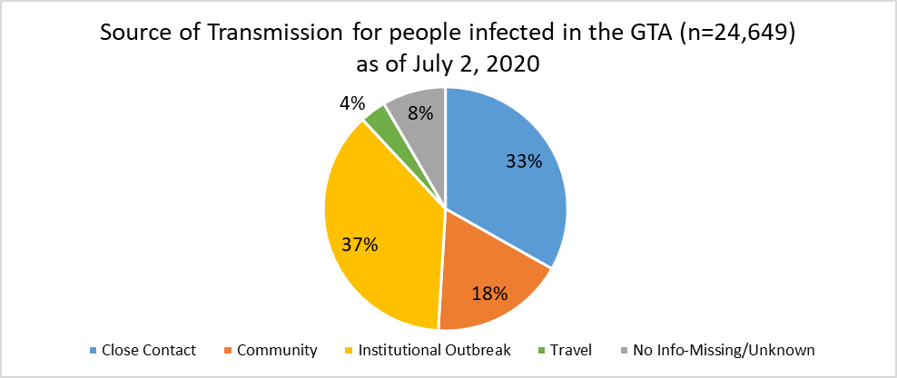
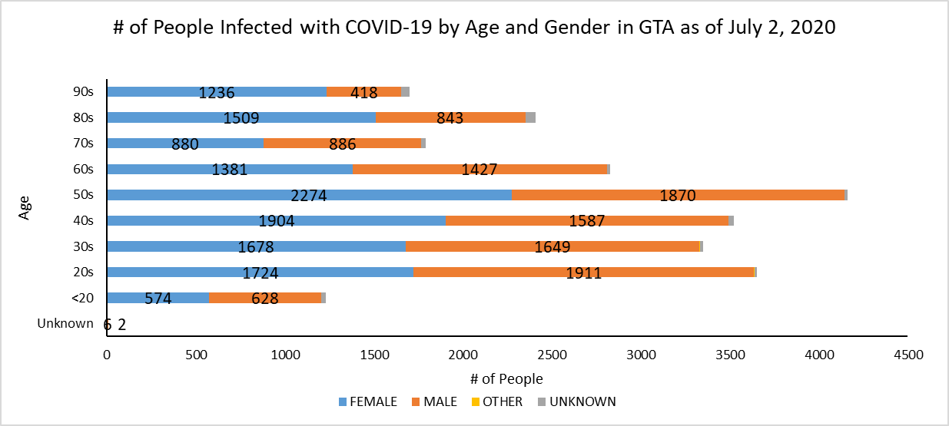
Footnote: There are a total of 15 cases where gender was indicated as “Other” (including “Transgender”) and another 247 cases where gender was unknown.
Source: Data as of July 2, 2020 (extracted from https://data.ontario.ca/dataset/confirmed-positive-cases-of-covid-19-in-ontario)

