COVID 19 Cases in Greater Toronto Area by Public Health unit
As of June 25, 2020
 | # of People Infected | # of Deaths | # of People Recovered
Durham Region Health Department | 1,680 | 180 | 1,459
Halton Region Health Department | 736 | 25 | 673
Peel Public Health | 5,654 | 304 | 4,882
Toronto Public Health | 12,897 | 1,034 | 11,233
York Region Public Health Services | 2,892 | 239 | 2,509
Overall GTA | 23,859 | 1,782 | 20,756

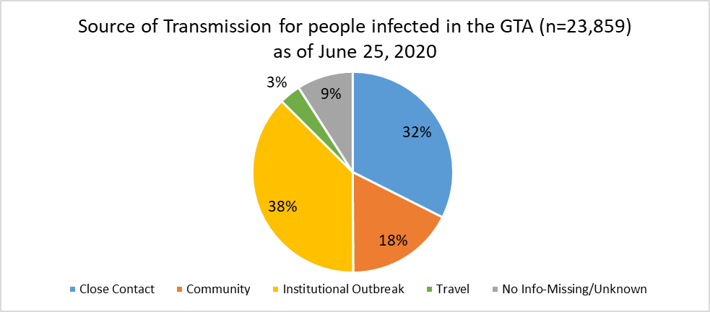
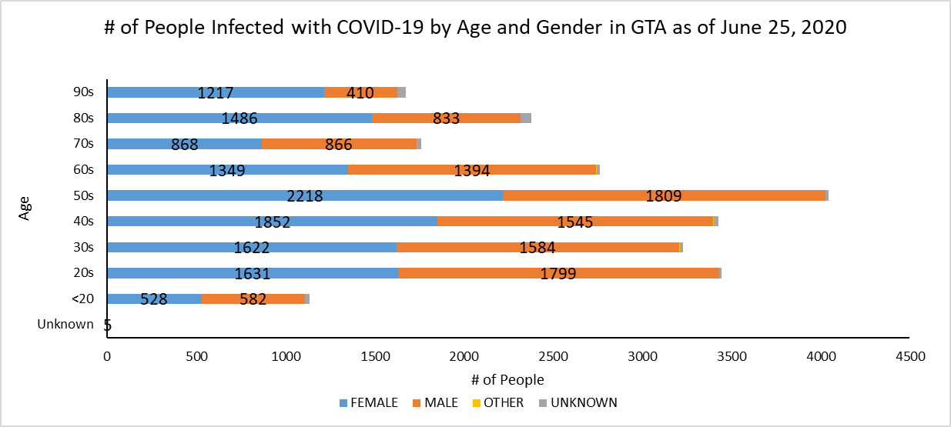
Footnote: There are a total of 13 cases where gender was indicated as “Other” (including “Transgender”) and another 248 cases where gender was unknown.
Source: Data as of June 25, 2020 (extracted from https://data.ontario.ca/dataset/confirmed-positive-cases-of-covid-19-in-ontario)

